**Topics: Descriptive Statistics and Probability**

1. Look at the data given below. Plot the data, find the outliers and find out $μ, σ, σ^{2}$

|  |  |
| --- | --- |
| **Name of company** | **Measure X** |
| Allied Signal | 24.23% |
| Bankers Trust | 25.53% |
| General Mills | 25.41% |
| ITT Industries | 24.14% |
| J.P.Morgan& Co. | 29.62% |
| Lehman Brothers | 28.25% |
| Marriott | 25.81% |
| MCI | 24.39% |
| Merrill Lynch | 40.26% |
| Microsoft | 32.95% |
| Morgan Stanley | 91.36% |
| Sun Microsystems | 25.99% |
| Travelers | 39.42% |
| US Airways | 26.71% |
| Warner-Lambert | 35.00% |

In given data mean is 33.27% ,standard deviation is 16.94% and variance is 2.87%.

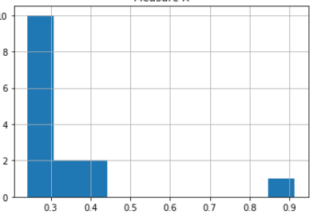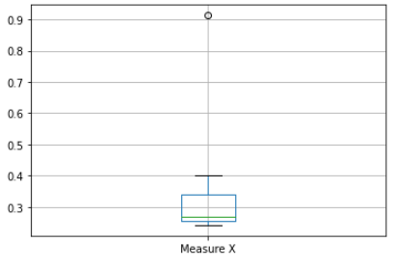

In given data Morgan Stanley is a outlier.



Answer the following three questions based on the box-plot above.

1. What is inter-quartile range of this dataset? (please approximate the numbers) In one line, explain what this value implies.

Inter-quartile range is 7.Range for the middle 50% data is 7.

1. What can we say about the skewness of this dataset?

Positively Skewed

1. If it was found that the data point with the value 25 is actually 2.5, how would the new box-plot be affected?

There will be no outlier in the data.



Answer the following three questions based on the histogram above.

1. Where would the mode of this dataset lie?

Mode of the data set would lie on highest pick on the histogram . It will be lie in between 4 to 8.

1. Comment on the skewness of the dataset.

Right skewed (Positively skewed)

1. Suppose that the above histogram and the box-plot in question 2 are plotted for the same dataset. Explain how these graphs complement each other in providing information about any dataset.

Histogram are better in displaying the distribution of data. But we can use boxplot

to tell if the distribution is symmetric or skewed. Histogram is determining the probability distribution of data and boxplot giving us idea about spread of data.

1. AT&T was running commercials in 1990 aimed at luring back customers who had switched to one of the other long-distance phone service providers. One such commercial shows a businessman trying to reach Phoenix and mistakenly getting Fiji, where a half-naked native on a beach responds incomprehensibly in Polynesian. When asked about this advertisement, AT&T admitted that the portrayed incident did not actually take place but added that this was an enactment of something that “could happen.” Suppose that one in 200 long-distance telephone calls is misdirected. What is the probability that at least one in five attempted telephone calls reaches the wrong number? (Assume independence of attempts.)

A = 1 out of 200 calls getting misdirect.

P(A)=1/200

P(B) = 1-P(A)

= 1-0.005

P(B)=0.995

n=5

X= at least one in five attempted telephone calls reaches the wrong number.

X ~ B(n,p)

X ~ B(5,0.005)

pmf. of binomial Distribution

p(x) = $C_{x}^{n}.p^{x}.q^{n-x}$

= $C_{1}^{5}.p^{1}.q^{5}$

=0.02450

1. Returns on a certain business venture, to the nearest $1,000, are known to follow the following probability distribution

|  |  |
| --- | --- |
| X | P(x) |
| -2,000 | 0.1 |
| -1,000 | 0.1 |
| 0 | 0.2 |
| 1000 | 0.2 |
| 2000 | 0.3 |
| 3000 | 0.1 |

1. What is the most likely monetary outcome of the business venture?

Most likely monetary outcome of the business venture is 2000.

1. Is the venture likely to be successful? Explain

Probability of loss is

P(-2000)+P(-1000)=0.2

Probability of Profit is

P(1000)+P(2000)+P(3000)+P(0)=0.8

Probability of Profit is more than Probability of loss. Hence venture likely to be successful.

1. What is the long-term average earning of business ventures of this kind? Explain

long-term average earning of business ventures  = E(X)

E(X) = ∑ X.P(X)  = **$ 800**

1. What is the good measure of the risk involved in a venture of this kind? Compute this measure

V(x) = E($x^{2}$) - E{(x)}^2

=2800000 - 640000 =2160000

SD= $\sqrt{2160000}$ = 1469.694

As **Variability is high**  hence **Risk is high**